Minutes of the Me ting of the Wheatland Family & Community Support Services (WFCSS) held at the Wheatland County Offices, June 22, 2022

Chair:

WFCSS Interim CAO Recording Secreta :
D. Burke, Village of Rockyford (regrets)
C. Schindel, Village of Hussar
R. Bryan, Village of Standard
D. Biggar, Wheatland County
S. Laprise, Wheatland County
A. Geeraert, Village of Rockyford (alternate)

C. Gaudet
C. Harder

Call to Order and related Business

BIGGAR CALLED the meeting to order at 7:04pm

Resolution 22-06-17 Approval of
Agenda

LAPRISE MOVED approval of the agenda.

Carried.

Resolution 22-06-18 Approve Regular Meeting

SCHINDEL MOVED approval of the amended minutes of the Regular Boarc Meeting of June 1, 2022.

Carried.

Reports

Resolution 22-06-19
Financial Services

Resolution 22-06-20
Financial Services

Staff Reports

BRYAN MOVED to accept the Financial Statements for May 2022 as presented.
Carried.

LAPRISE MOVED approval of the May 2022 Reconciliation report for WFCSS as presented.

Carried.

Resolution 22-06-21
Financial Services

Resolution 22-06-22
Financial Services

Resolution 22-06-23 Staff Report Operations

BRYAN MOVED acceptance of the monthly GIC report as presented.
Carried.

BIGGAR MOVED acceptance of the May 2022 payroll report as presented.
Carried.

BRYAN MOVED approval of the Operations Report as presented. Key points of interest include Lunch and Learn update, Meals on Wheels, Good Food Box, request for an AEMA Representative and a potential grant opportunity to be circulated at a later date by email.

Carried.
Next Meeting:

Regular Meeting July 27, 2022 @ 7:00pm at Wheatland County offices. (C. Gaudet to act as
recording secretary)

Adjournment

Resolution 22-06-24
Adjournment

SCHINDEL MOVED to adjourn at 7:30pm.

Carried.

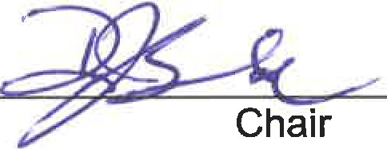
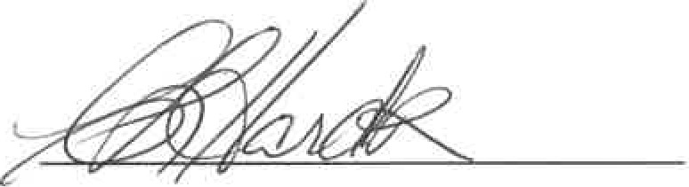

Recording Secretary

