Minutes oft e Meeting of the Wheatland Family & Community Support Services (WFCSS) held via ZOOM, July 27, 2022

Chair:

WFCSS Interim C 0

AVAIL Partner:
D. Burke, Village of Rockyford
C. Schindel, Village of Hussar
R. Bryan, Village of Standard
D. Biggar, Wheatland County
S. Laprise, Wheatland County

C. Gaudet (Interim Recording Secretary) Darren Adamson (7:11pm-7:25pm)

Call to Order and related Business

BIGGAR CALLED the meeting to order at 7:04pm

Resolution 22-07-01
Approval of Agenda

BIGGAR MOVED approval of the agenda.

Carried.

Resolution 22-07-02 Approve Regular Meeting

Minutes from June 22, 2022 meeting deferred to September meeting as they wen not attached to board package.

Carried.

Reports

Resolution 22-07-03
Financial Services

Staff Reports

LAPRISE MOVED to accept the Financial Statements for June 2022 and as presented and the 2021 Engagement Review as presented by Darren Adamson from Avail.
Balance of 2022 municipal funding to be paid to WFCSS. Bookkeeper will issue invoices.

Carried.

Resolution 22-07-04
Financial Services

BIGGAR MOVED approval of the June 2022 Reconciliation report for WFCSS as presented.
BURKE Requested to have all names removed from submitted financial reports due to FOIP.

Carried.

Resolution 22-07-05
Financial Services

Resolution 22-07-06
Financial Services

BURKE MOVED reinvest of GIC #722821415006 for a period of 12 months effective September 3, 2022. acceptance of the monthly GIC report as presented
Carried.

BRYAN MOVED acceptance of the June 2022 payroll report as presented.
Carried.

Resolution 22-07-07 Staff Report Operations

BRYAN MOVED approval of the Operations Report as presented. Key points of interest include Good Food Box, Home Support, Compass for the Caregiver, lnteragency Council and additional training. Fax line has been removed and file clean up process is underway.

Next Meeting:
Regular Meeting

Adjournment
Carried. September 28, 2022 @ 7:00pm at Wheatland County offices.

Resolution 22-07-08
Adjournment

BURKE MOVED to adjourn at 7:41pm.

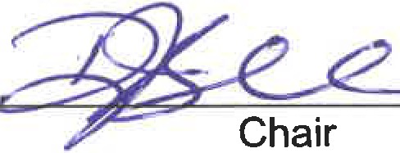Carried.

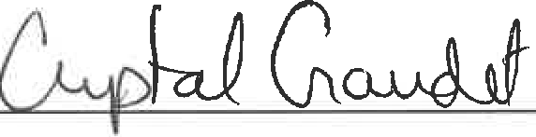
Recording Secretary

