heatland Family and Community Support Services (WFCSS) Regular Meeting Minutes of September 28, 2022

Minutes oft e Meeting of the Wheatland Family & Community Support Services (WFCSS) WFCSS Office (ECC Room), September 28, 2022

Chair:
Vice Chair:

WFCSS CAO
Recording Secreta

Call to Order and related Business
D. Burke, Village of Rockyford
D. Biggar, Wheatland County
C. Schindel, Village of Hussar (via Zoom)
R. Bryan, Village of Standard
S. Laprise, Wheatland County

C. Gaudet (Interim Recording Secretary)
C. Harder (Regrets)

BURKE CALLED the meeting to order at 7:02pm

Resolution 22-09-01 Approval of Amended Agenda

BIGGAR MOVED approval of the amended agenda.

Carried.

Resolution 22-09-02 Approve Regular Meeting

BRYAN MOVED the adoption of meeting minutes from June 22 and July 2'. meetings.

Carried.

Items for Discussion

Resolution 22-09-03
Avail Audit Shield

New Business

BRYAN MOVED to purchase Audit Shield from AVAIL from one year, contract ending September 30, 2023

Carried

Resolution 22-09-04
Surplus Funding

BURKE MOVED CAO to write a letter to the 2022 Funding Recipients to gauge interest in receiving additional funding on the terms they can use and report outcomes by December 31, 2022. Response deadline October 7th, 2022
Carried

Resolution 22-09-05
Donations

BRYAN MOVED donations received (In memory of Lynn) used to purchase gas cards and grocery cards for families in need residing in Wheatland County.
Donations total $500.00 $25.00 for gas and $50-$100 for grocery.
Carried

Resolution 22-09-06
FCSSAA Conference

Resolution 22-09-07
Grant Application

D. Biggar, S. Laprise and C. Gaudet will attend the conference in Edmonton November 16-18.

PRISE MOVED the grant application for the WRREH approved. Previous approve

I heatland Family and Community Support Services (WFCSS)
t
Regular Meeting Minutes of September 28, 2022

ia email due to application deadline.
Carried

Resolution 22-09-08
Records Disposition

BRYAN MOVED to have boxes 22-1 and 22-2 destroyed with Wheatland County records disposition.

Carried
CAO will research options on moving records storage to electronic and secondary data storage options.

Resolution 22-09-10
Commissioner of Oaths

LAPRISE MOVED to approve CAO's application for Commissioner of Oaths.
Carried

Resolution 22-09-11 Credit Cards/ Cheque Listing

Resolution 22-09-12
Meals on Wheels

BIGGAR MOVED to accept report on credit card purchases as information received
Carried
CAO to provide a listing of cheques and e-transfer completed for the month at boarc meetings moving forward.

SCHINDEL MOVED to accept report on Meals on Wheels price increase as information received.

Carried

Reports

Resolution 22-09-13
Financial Services

Staff Reports

BIGGAR MOVED to accept the Financial Statements for July and August 2022 and as presented.

Carried.

Resolution 22-09-14
Financial Services

LAPRISE MOVED to approve the July and August 2022 Reconciliation report for WFCSS as presented.

Carried.

Resolution 22-09-15
Financial Services

BURKE MOVED to approve the GIC report as presented. CAO to investigate the low interest rate on GIC #722821415006.

Carried.

Resolution 22-09-16
Financial Services

BIGGAR MOVED acceptance of the July and August 2022 payroll report as presented.

Carried.

Resolution 22-09-17 Staff Report Operations

SCHINDEL MOVED approval of the Operations Report as presented. Key points of interest include Home Support, Collective Cooking, Compass for the Caregiver lnteragency Council and additional training.
CAO to start working with bookkeeper on 2023 budget. To be presented Dec/Jan
Carried.

heatland Family and Community Support Services (WFCSS) Regular Meeting Minutes of September 28, 2022

Correspondence

Acceptance Letter

Next Meeting:
Regular Meeting

Adjournment
CAO presented letter of acceptance for job position effective May 1, 2022.

October 26, 2022 @ 7:00pm at Wheatland County office.

Resolution 22-09-18
Adjournment

BURKE MOVED to adjourn at 8:05.

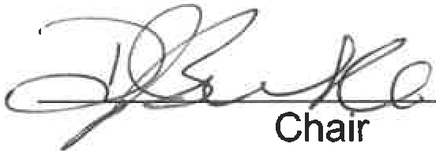
Carried.

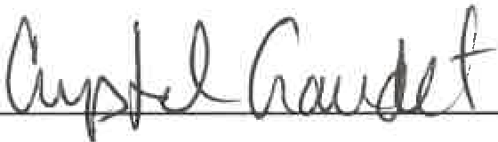Recording Secretary

