Minutes of the Me
ting of the Wheatland Family & Community Support Services (WFCSS) held at the Wheatland County Offices, October 26, 2022

Chair:

WFCSS CAO
Recording Secreta

Call to Order and related Business
D. Burke, Village of Rockyford
C. Schindel, Village of Hussar
R. Bryan, Village of Standard
D. Biggar, Wheatland County
S. Laprise, Wheatland County

C. Gaudet
C. Harder

BURKE CALLED the meeting to order at 7:01pm

Resolution 22-10-01
Approval of Agenda

BIGGAR MOVED approval of the amended agenda. (Addition: 2.1.b. Truth & Reconciliation Day)

Carried.

Resolution 22-10-02 Approve Regular Meeting

LAPRISE MOVED approval of the amended minutes of the Regular Board Meetin of September 28, 2022.

Carried.

New Business

Resolution 22-10-03
Credit Card Payments

BIGGAR MOVED that WFCSS accept credit card payments as presented, with nc additional administrative cost to clients.

Carried.

Resolution 22-10-04
Truth & Reconciliation BURKE MOVED acceptance of September 30, 2023 Truth & Reconciliatio1 information - office will only be closed to walk-in public.
Carried.

Reports Staff Reports

Resolution 22-10-05
Financial Services

BIGGAR MOVED to accept the Income Statement for September 2022 as presented.

Carried.

Resolution 22-10-06
Financial Services

BRYAN MOVED approval of the September 2022 Reconciliation report for WFCSS as presented.

Carried.

Resolution 22-10-07
Financial Services

SCHINDEL MOVED acceptance of the monthly GIG report as presented.
Carried.

Resolution 22-10-08
Financial Services

Resolution 22-10-09 Staff Report Operations

BIGGAR MOVED acceptance of the September 2022 payroll report as presented.
Carried.

SCHINDEL MOVED approval of the Operations Report as presented. Key points of interest included ESS Directors Meeting, Good Food Box, Home Support, Wellness Bags, Senior Power and CAO Meetings and Gas / Grocery card assistance.

Carried.

Resolution 22-10-10
Grocery & Gas Cards

BRYAN MOVED a two time / year limit on access to grocery and gas care assistance.

Next Meeting:
Regular Meeting November 23, 2022 @ 7:00pm at Wheatland County offices.

Adjournment

Resolution 22-10-11
Adjournment

BRYAN MOVED to adjourn at 7:28pm.

Carried.

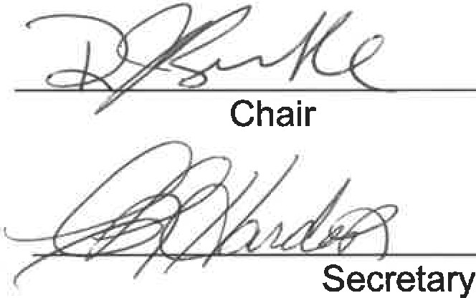
Recording

