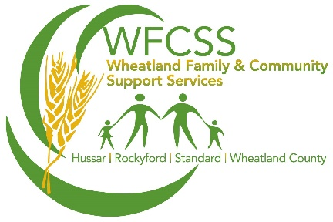
Are you turning
65 soon?

You may be eligible for Federal financial assistance programs:
- Canada Pension Plan (CPP)
- Old Age Security (OAS)
- Guaranteed Income Supplement (GIS)
6 months before you turn 65 you should receive a Seniors Financial Assistance package in the mail containing information on:
- Alberta’s Seniors Benefit (ASB)
- Special Needs Assistance for Seniors (SNA)
- Dental and Optical Assistance for Seniors
Based on our income you may also qualify for:
- Seniors Property Tax Deferral Program
- Seniors Home Adaption and Repair Program (SHARP)
- Prescription drug and health related coverage (Blue Cross)
WFCSS can assist you with completing and submitting these applications. If your income or marital status recently changed you may qualify for one or more of these programs that you did not qualify for last year. Come and chat with us to discuss your options.
We can also assist you with obtaining a SIN, Birth Certificate or Proof of Age forms as you will be required to provide some form of documentation.
Call us at 403-934-5335, email us at info@wfcss.org or drop by the office between 9am-4:30pm located at 242006 Range Road 243, Wheatland County Municipal Operations Building on Hwy 1.

